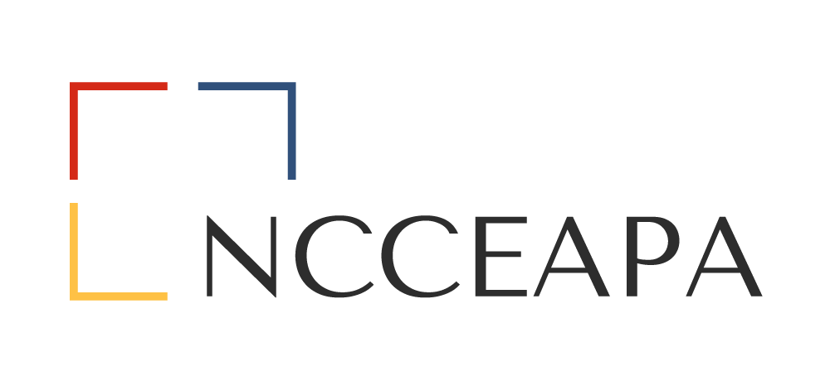
SOUTHEAST DISTRICT PROFESSIONAL IMPROVEMENT COMMITTEE GUIDELINES

The purpose of this committee is to keep association members up to date with awards and scholarships available to them with deadlines and criteria, workshops and trainings available, and any magazines, internet pages, etc. that would help in the education and time management of all members.

PROCESSES AND NOTIFICATION REMINDERS for Awards and Scholarlships
Note: If a member of the judging committee for any award or scholarship receives a nomination, that member will abstain from serving as a judge.
At the Spring District Meeting notify/remind all members of the Association of the awards and scholarships with deadlines and criteria for each.
State Level:
- Distinguished Service Award; District nominations to be submitted to the District Professional Improvement Committee Chair (DPICC) by July 1 to determine district winner. The DPICC will submit the district winner to the State 1st Vice-President by August 1; process initiated and coordinated by State 1st Vice-President
- Executive Board Award; nominations to State 1st Vice-President by August 1; process initiated and coordinated by State 1st Vice-President
- Sue Mills Lighthouse Award; nominations to State President by August 1; process initiated and coordinated by State President

District Level:
- Southeast District Administrative Professional of the Year; handled by District Nominations Committee Chair (District Advisor); due by August 1
At the Fall District meeting notify/remind all members of the Association of the awards and scholarships with a spring or April 1 deadline.
State Level:
- Herter-O’Neal Award; handled by State 2nd VP and District Professional Improvement Chair; District deadline is mid-March - to be determined yearly by District Professional Improvement Chair; see timeline for various deadlines
District Level:
- District Professional Improvement Scholarship; April 1 deadline; (See process below)
- Southeast District 4-H Scholarship (See process below)

Professional Improvement Scholarship Application Process
District Professional Improvement Scholarship
- Beginning the second Tuesday in January, Professional Improvement Chair will provide to all District Admins with a copy of the Professional Improvement Scholarship Application. Applications are due by April 1 of that year.

- The Professional Improvement Committee will review the applications, choose a recipient by August 1st and notify the District President and Treasurer. Once the President approves the selection, the Treasurer will communicate with the recipient regarding disbursement.

- The Scholarship recipient will be announced at the fall meeting of the Southeast District Admins Association and a check will be presented at that meeting.

4-H Scholarship Process
Southeast District 4-H Scholarship
- At the Fall District meeting announce the next county in line for the scholarship. County rotation is handled alphabetically based on Association participating counties.
- An update from the county receiving the recently awarded scholarship will be presented on how scholarship funds were used.

Herter-O’Neal Scholarship Application Process
Herter-O’Neal Scholarship
- By January 10th the State 2nd VP is to notify the district chairs of the Professional Improvement Committee (which comprise the state Professional Improvement Committee) of scholarship guidelines, details, and deadlines for entries.

- By January 15th the District Chair of the Professional Improvement Committee is to provide all District Admins with a copy of the Scholarship Guidelines, Application details, address for submission and deadline for entries (which should be at least 2 weeks prior to April 1st).

- By January 20th the County Admins in turn are to notify any and all Financial Aid Officers at local colleges and Counselors at high schools of the Scholarship opportunity and provide application materials to include brochure, application form, and links to the NCCEAPA website regarding this award for more information.

- All completed applications should be returned to the District Chair of the Professional Improvement Committee. The Professional Improvement Committee will review and judge all applications, using the provided Judging Sheet, to determine the candidate for the Southeast District. That Application is then forwarded to the State 2nd VP by April 1st (firm deadline established by the State) for final selection at the State level.

All applications and guidelines for State level awards are available at: https://ncceapa.ces.ncsu.edu/awards-and-scholarships/

All applications and guidelines for District level awards are available at: https://ncceapa.ces.ncsu.edu/districts/ncceapa-southeast-district/awards-and-scholarships/

