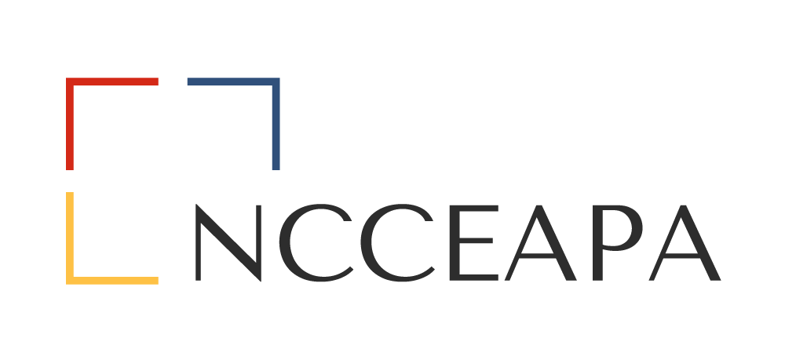

NCCEAPA
STATE CONFERENCE
PLANNING MANUAL
Revised March 2024

TABLE OF CONTENTS

- INTRODUCTION
- COMMITTEES
  - Steering Committee Co-Chairs
  - Venue
  - Finances
  - Invitations
  - Workshops
  - Registration
  - Banquet/Decorations
  - Program
  - Community Service Project
  - Door Prizes/Favors
  - TERSSA (The Extension & Research Support Staff Association)
- CONFERENCE TIMELINE

INTRODUCTION
This booklet contains general and specific information on how to begin and conduct your planning for the year your district is to host the state NCCEAPA meeting. It is by no means a catch all book. It is designed to take a lot of the guesswork out of your planning and to provide helpful suggestions. It is also a useful guide to make sure you don’t miss any important steps.
COMMITTTEES
Steering Committee
- Once the date for the conference has been confirmed and approved, the Steering Committee should immediately notify the NC State President who will then immediately notify the TERSSA President to hopefully avoid conference date conflicts.
- Usually chaired by district president and another district officer.
- Main purpose is to make sure that all committee functions are accomplished appropriately and in a timely manner. May have to make some executive decisions.
- Along with the District Treasurer, monitor the overall budget.
- Post-registration (workshop/banquet) information into XLMS site for registration. Make sure to not only include your workshops but the Executive Board of Directors Meeting, the Board of Directors Meeting, the Business Meeting, and the banquet.
Venue
- Start search at least 18 months in advance looking for a hotel large enough to meet NCCEAPA requirements. Also be mindful that you will need a place to put together and store your registration/goody bags. It’s preferable that the hotel gives you a space with no extra charge.
- All contact with the sales office at the facility should be made by the same person throughout the planning to avoid confusion and maintain efficient communication. That same person, along with the President, will be the ones to sign the contract. It is recommended to keep open communication within the district at all times during the planning process.
- MUST HAVE APPROVAL OF DATES and AGENDA BY ADMINISTRATION PRIOR TO SIGNING ANY CONTRACTS
- **SIDE NOTE** NE DISTRICT ONLY** The President and 1st VP are the ones who sign contracts as they make up your board.
Finance
- Ask each county to be responsible for donating a particular amount of money or items (Previous donation amount had been $100 per member). ** This “fundraiser” will vary by districts!! It is not something that you have to do.
- Prepare a template letter requesting donations from businesses/groups/individuals- this template will be used to contact possible donors from each county in the district. We may already have good examples available.
- Request donations ON THE DISTRICT LEVEL from the other organizations such as a county’s local Farm Bureau.
- Propose and implement fundraising events if desired (raffles, white elephant sales, etc.)

Invitation
- Should be prepared after securing date and location.
- The committee will prepare an invitation to present at the prior state meeting. If you are contemplating the use of technology, check with the local travel and tourism department for the area. They may already have something prepared that you can utilize, or you can create your own.
- Make the host district aware of any devices needed for the presentation if you are not able to bring your own.
- If planning to distribute any written information or brochures, etc. for the upcoming conference, have bundles ready to pass out after presentation.
- Once the official date had been secured, send out a reminder “SAVE THE DATE” email so people can put on their calendars.
- “EARLY BIRD REGISTRATION” should be made available by late March/early April with due date by June 30th so that counties who allow funds to be paid out of that fiscal year can do so.
Workshops
- Propose workshop topics and instructors!
- Secure needed information about topics and instructors
- Suggest banquet speaker. **Do they need equipment, or will they bring their own? It may be part of their contract that we provide any necessary equipment. ** Read the contract carefully!!
- Maintain spreadsheet with names and workshop choices/times/location.
(All of the above bullets must be approved by Extension Administration, especially before any contracts between the banquet speaker and hosting district are signed)
- Determine cost involved for instructors/speakers.
- Help design and print programs (optional)
- Be aware of proper logo(s) needed for materials provided by instructors.
- Make sure you contact instructors to see if they need you to make copies of any materials they will be presenting. Also take note of any equipment they may need.
- Make sure you have adequate sign-in sheets for each workshop. This is mainly for those who didn’t sign up in XLMS. The person responsible for setting up the classes in XLMS will have to manually enter the participants in for those who didn’t sign up for the class in advance or were on a waiting list.
- Consult with other related committees as necessary.
Registration
- Receive copies of registration forms and fees (usually by committee member and/or Treasurer; helpful if both are in the same office)
- Maintain spreadsheet with names, counties, district, type of attendee (member, member guest, administration)
- Provide steering committee list of names to determine who should be recognized at banquet (i.e., Administration from A&T and NCSU, etc). Maybe give a general recognition of spouses/significant others. Just a welcome; nothing they need to stand up for.
**SIDE NOTE- all administration from both universities (instructors included) are to pay their own hotel, and food fees from their respective travel. NCCEAPA DOES NOT COVER THAT COST!!!
- Put together registration packets for each participant (receipts, agenda, tickets, etc.)
- Transport registration packets to meeting.
- Determine schedule for manning of registration desk at meeting and solicit volunteers.
Banquet/Decorations
- Propose menu for banquet for approval of steering committee (or district)
- Prepare place cards/tent cards for head table.
- Propose centerpieces for table for banquet/business meeting. It’s always a good idea to consider incorporating agriculture and your theme in your decoration if possible.
- Purchase and/or make items for centerpieces.
- Make sure the necessary equipment is set up at the head table (this is also something that the person finding the venue needs to keep up with; mainly to see if there is a charge for using hotel equipment. (If there is no charge it’s easier to use theirs than transport your own equipment.)
- Make sure your decoration committee knows in advance the time you will be setting up. You will have to do it twice. Once for banquet and once for business meeting on Friday. **Words of wisdom** It’s easier to do full decoration for banquet and simply take away a few pieces for the business meeting than to have a whole other set of decoration. It is also a good thing to raffle off decorations than to have to pack it up and haul it away yourselves, UNLESS, you borrowed the decorations. Also, ask your hotel, they may already have something you can use.
Programs
- Secure needed information from state president and planning committee chairs (registration, workshops, meetings, past presidents’ breakfast, etc.)
- Program should reflect conference schedule with time and daily activities.
- Banquet or Luncheon (depending on preference) program should reflect speakers, entertainment, mealtime, awards recognition, and any special guests.
- Programs should be designed to reflect the theme.
- After receiving approval programs may be printed
Community Service Project
- Ask attendees to bring items that can be donated to a local non-profit organization (food bank, shelter, hospice, soup kitchen, etc.)
- Determine recipient/acknowledgement of items (who, when and how items will get to desired destination)
- Provide items appropriate for donation to program committee to include with email/online registration form.
Door Prizes/Favors
- With input from general membership determine what, if any, favors should be given.
- Determine number of door prizes and system for distributing them at the end of the business session.
- Items should be of specified value.
- Items should be appropriate for either female or male attendee.

TERSSA – The Extension & Research Support Staff Association:
- As directed/recommended by Extension Administration, TERSSA and NCCEAPA will hold a conjoint conference the year North Carolina holds the President seat for TERSSA.
- TERSSA President will work with TERSSA Annual Meeting Committee Chairperson, along with NCCEAPA President, District President hosting the annual conference, and District Planning Committee Chair in order to have a clear understanding of what is needed to ensure a successful conjoint conference for both associations.
- Efforts are to be made to incorporate both associations in functions during the entire conference, i.e. professional development seminars, business meetings, tours, award presentations, etc. where applicable.
- If ever the decision is made to host a stand-alone TERSSA Annual Conference, directives listed above should also be followed.
CONFERENCE TIMELINE FOR COMMITTEES
- Develop Steering Committee
- Scout Venue-Start scouting 18 months out; reserve tentative dates.
- Obtain approval from Administration for dates and tentative agenda.
- Sign contracts for venue to secure dates and any other contracts needed.
- Inform State NCCEAPA President of dates who will inform the TERSSA President.
- Notify hosting District members of dates; provide instructions for fundraising and donations expected from each county.
- Finance - prepare budget.
- Invitations-Prepare any hard copy invitations; begin preparing invitation video to be presented at current year’s state meeting.
- Workshops – begin building workshops, securing presenters, supplies needed, offsite activity.
- Registration – Prepare registration forms, set pricing for registration tiers; set up tracking spreadsheet for all incoming receipts; begin building list of items for registration packets (1) to be emailed and (2) what to be given out at actual registration.
- XLMS- Enter all activities and meetings into XLMS.
- Community Service – determine project, prepare flyer to send with registration packet.
- Programs – Begin building program for actual event reflecting activities, workshops, speakers, sponsors, etc.
- Door Prizes/Favors – decide on items and collect.

