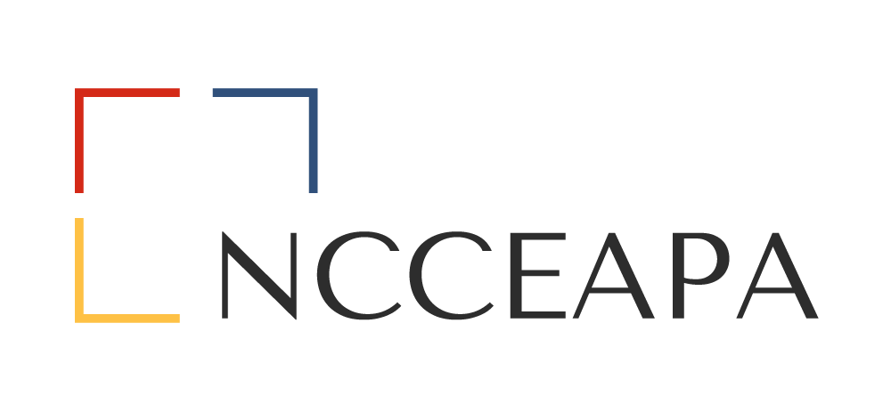
Sue Mills Lighthouse Award
Spirit of Light Nomination Form
Nominee:
County/or Department:
Address:
Nominated by:
Nominator Telephone Number:
Nominee Telephone Number:
Selection of the Sue Mills Lighthouse “Spirit of Light” award winner will be based on the nomination narrative. This award is designed to recognize an individual who has made a difference.
In narrative form, describe how your nominee has been an inspiration to you in such a manner that you consider them worthy of being described by the statement “Spirit of Light” in memory of Susan Austin Mills.
Narrative should include:
- How and why the nominee has been an inspiration to you
- How the individual has made a difference within the organization
- Leadership qualities
- Enthusiasm and zest for life
- Your personal reflection “from the heart” on why you think your nominee should be recognized as a “Spirit of Light”.
Please limit narrative to no more than two (2) pages, typed/double spaced, and 12 pt font.
Send to: Roben Jarrett, NCCEAPA State President
6206 Oleander Drive
Wilmington NC 28403
Email: roben_jarrett@ncsu.edu

Deadline: August 1, 2024 by 5 pm. Late submissions will not be considered.

