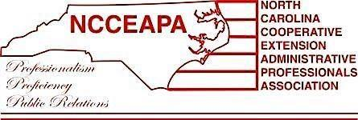

Southeast District
Standing Rules

North Carolina Cooperative Extension Administrative Professionals Association
Constitution and Bylaws

Article XIV – District Procedures
Section 1:
The Districts shall follow the same Constitution and Bylaws as outlined for the State.
Section 2:
Districts may add rules which are pertinent to local or district affairs and which are not in contradiction to the State Constitution and Bylaws.

How these standing rules are established according to Constitution and Bylaws:
Article XVI – Amendments
Section 1: Amendments to these [Standing Rules] may be made at any meeting of the general membership by a two-thirds majority vote of those present, after notification in writing to each member at least two weeks before the meeting at which the voting is to take place; or, if the emergency of the measure so dictates, by a two-thirds vote of written ballots returned.

The following is a list of Standing Rules officially adopted by the members of the Southeast District:

Rule Number | Title | Description  (including who is responsible for the action, if any) | General Meeting date that this rule was adopted/amended
1 | Awards & Scholarships | The Southeast District will give a $100 scholarship (selected by alphabetical order) to the county 4-H agent(s) of active NCCEAPA-SED members. | Spring 2017 (?)
2 | Committee Structure | In addition to the Standing Committees defined in the NCCEAPA Constitution and Bylaws (Article XII, Section 1), the Southeast District will have a Goodwill & Benevolence Committee. | May 31, 2019
3 | Committee Structure | The Southeast District will combine the Public Relations and Reflections Committees to create the Public Relations/Reflections Committee. | May 6, 2021
4 | Awards & Scholarships | Each year the NCCEAPA-Southeast District Chapter will present the Administrative Professional of the Year Award to a Southeast District association member who has exhibited notable participation, contributions and cooperation with the association. The award will be $100 and a certificate. | May 6, 2021
5 | Membership for New COSS | When a COSS staff member is hired, the association will waive the registration fee of their first meeting with or without membership; membership is required in order to have voting rights. | April 22, 2022
6 | Yearly Dues | Yearly dues for the SED are not prorated, regardless of when a person joins the association. | August 16, 2022

