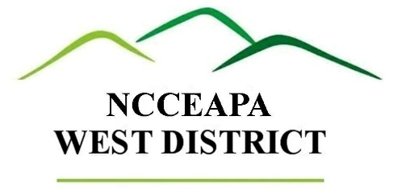

Date

To: NC CE West District CEDs
From: NCCEAPA West District Membership

The West District NCCE Administrative Professional Association is seeking nominations for the Administrative Professional of the Year Award. This award is an excellent way to acknowledge and reward the contribution that your Cooperative Extension Administrative Assistant is making to your office, county and the state of North Carolina. The winner of this award will receive a certificate and $100, presented at the fall meeting of the NCCEAPA West District Meeting.

Guidelines:

Any member of the nominee’s Extension staff can nominate their AA for the Administrative Professional of the Year Award.
An active member of the NCCEAPA West District can also nominate another AA for this award.
Deadline for nominations will be August 1, ____.
Nominees must be active members of the North Carolina Cooperative Extension Administrative Professional Association and attend at least one of the two West District NCCEAPA meetings within the last year and must have a minimum of three years’ service with North Carolina Cooperative Extension.
The administrative professional selected as a winner will not be eligible to become a nominee again for a period of five years.

The official nomination form is attached to this email.

If you have any questions, please contact_______________________________________________________.

Thank you for taking time to recognize the contributions of your Administrative Assistants and I look forward to receiving your nominations!

Sincerely,

Attachment

