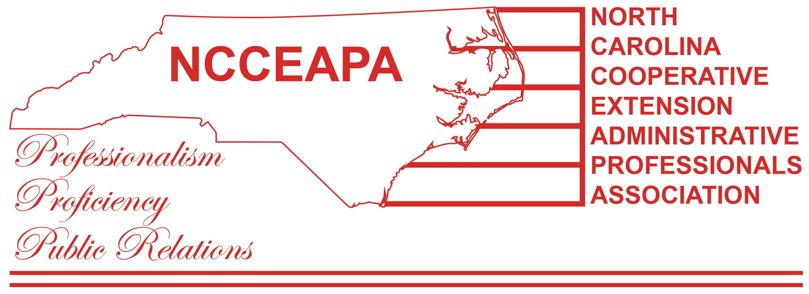
NCCEAPA – Southeast District – Spring General Meeting, May 22, 2020 via Zoom

President Michelle Kasey called the meeting to order at 2:10 pm via zoom.

The roll was called. Detail by county not captured. A total of 23 members attended.

Bladen |  | Lenoir
Brunswick |  | New Hanover
Campus |  | Onslow
Carteret |  | Pamlico
Columbus |  | Pender
Duplin |  | Robeson
Green |  | Wayne
Sampson |  | Craven
Jones |  | Wilson
 |  | Total

Roben Jarrett, Parliamentarian, verified quorum.

Thought for the Day was submitted by Regina Gardner; “Corona Virus Poem” written by Regina.

Approval of the minutes for the Fall 2019 Meeting and Spring 2020 BOD/State Planning Committee Meeting was tabled. Minutes were not available for review. Minutes will be emailed for vote. Voted on and motion carried.

Kareis Britt – District Treasurer, gave the finance report. Balances reviewed. An update of monies paid to retirees was presented.

Standing Committee Reports:

Finance: Kareis Britt - Finance Committee Chair reported that dues are coming in and that the deadline is September 15, 2020 for all dues to be paid. (Report attached)

Membership: Danyce Dicks – Craven, Lenoir and Wayne Counties are not participating and stated they were not interested in doing so

Nominating : Roben Jarrett – Nomination Committee Chair sent nominations form via Google Docs. Main emphasis on re-establishing the line of succession. Currently: Secretary is open with Wanda Hargrove volunteering to continue with nomination; Treasures is filled; Emily Walter will continue as 2nd VP; 1st VP open. Michelle agreed to accept nomination to be President for this year. Send nominations to Roben. Slate of officers to be voted on at fall meeting. (Report attached)

Rules & By-Laws: Kimberly Hoskins –Kim met with Executive Board and voted on a change in State bylaws in Article 4 of Membership. A change in wording only. Deb and Emily are looking for a copy of our updated District bylaws.

Professional Improvement: Debbie Goncalves – see below

Public Relations: Wanda Hargrove – No report, Wanda absent

Reflections: Emily Walter – Reflection Chair stated that the State level is asking for selfies of what we have been doing during Covid. Please send to Emily and she will pass it on.

Benevolence: Nan Rackley – Benevolence Committee Chair submitted report that was read by Michelle.
Revised retirement amounts have changed. Cards have been sent out occasions; it is okay for individual offices to purchase gifts on your own. (Report attached)

Honorary Memberships – Michelle read report from LaToya. Trying to find out who has retired and did not get recognized. Reatha has rosters from members past and if there is an asterisk in the list of having received a check, then they still need a check. Have to be a member until retirement to receive the $100 check. This was put in place in 2010; if they retired before then they are not eligible. Guidelines provided today have been passed and motion carried.

From Suzanne Hugus – Bylaws are changed on “Honorary Members” – what is required to be honorary?

NCSU Staff Senate: Roben Jarrett – any updates will be emailed to membership

Webmaster – Roben Jarrett requested hi-res photos to be sent so membership page can be updated.

CAL Staff Advisory Council – report from LaToya was read by Michelle (report attached)

Old Business:

None noted

New Business:
- In-person State Extension Conference has been cancelled. Dr. Bonanno promised Admins would get to go next year. Suzanne asked for any ideas on training for this year’s virtual conference.
- Terms can only last one year, but we may volunteer to stay on additional year if we choose.
- Wants to implement some sort or mentoring system for those coming into a position.
- Deb Goncalves –Professional Development
  - Herter O’Neil winner decided
  - Moving date for Professional Development scholarship to April 1, choose recipient by August 1.
  - Taking out requirement of receipts. Allow recipient to use as they see fit
  - Changing time of exclusion from 5 years to 2 year exclusion
  - Taking out county rotation
  - Increase to $200, Southeast District members only; if no one gets the money it stays in the general funds
- Deb Goncalves - 4-H Scholarship
  - Keep alphabetical county rotation in, just issue the funds to the county that is up for rotation.
  - Funds go to the county and the 4-H Agent gets to decide how that money will best benefit the program
  - Voting on changes today; announcing eligible county for scholarship next meeting; motion carried. (Report attached)
- State Meeting Planning Committee – Allowing the NE District to continue the statewide meeting for 2021 and the SE District for the following year in 2022. Per Angie Pearsall, our location will be Downtown Wilmington. Things that have been decided on can carry over to 2022, but pricing may change. Postponement voted on and motion carried.
- Monies for Scholarships will be kept in our general funds and not do this until next year; motion carried.
- Motion to adjourn at 3:53 pm; Video provide by Suzanne Hugus for ending the meeting.

