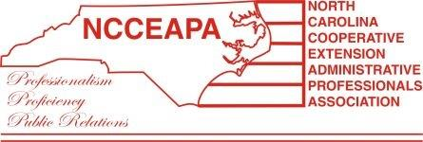

NCCEAPA Meeting & Holiday Lunch
December 14, 2019
Orange County Extension Center, Hillsborough NC

Present: Donna Holland, Suzanne Hugus, Bernadette Smith-Murray, Valarie Diggs, Lin Zhao, Crystal Headen, Karla Frizzelle, Evelyn Stahling, Lindsey Clark, Alice Pennix, Anita Wright

Call to Order: Evelyn Stahling, President called the meeting to order.

Review and approval of October 2018 minutes:
Crystal Headen made a motion to approve the minutes, Bernadette second, all approved. (with some minor corrections)

New Business:
Two of our members have retired:
Margaret Browne
Alexis Gaines

Anita will submit Margaret Browne for honorary membership status and Alice will submit Alexis Gaines for honorary membership status.

Next potential meeting dates:
April 10th or 11th – 2019
April 17th or 18th – 2019

Suggestion was made to combine our next meeting date with the community service project. (update: the community service project date is set for April 18th – Floral Arrangement Activity)

Suggestions made were Habitat for humanity, Soup Kitchens, Urban Ministry and Ronald McDonald House. Final decision was made via email from Evelyn Stahling with all group membership.

Financial Report:
Valarie Diggs – the new names for signature cards have been submitted to the bank.

Valarie will move $1726.49 from the checking account to the money market account. (see financial report submitted at the meeting for all balances)

Anita Wright - State Meeting discussion – Our next year to host the State meeting is 2022. There was some discussion about potential fund raising for that meeting. We do have funds now for that meeting. But we can do some more fund raising between now and then. The fundraising committee will work on this and report back with their suggestions.

Meeting was adjourned and we participated in our holiday luncheon catered by Rave.

